**COVID-19 CHALLENGE: HUMAN FACTORS**

Cristi Cioriia, Emanuele Silvio Gentile, Gabriel Perez, Ismail Uddin,

**Abstract:** The goal of the team was to investigate any link between population density, infrastructure density, air/land traffic, GDP per capita, and covid-19 cases growth rate and peak, looking at individual UK administrative regions (counties). The UK region was selected for its diversity of socio-economic indicators but at the same time the accuracy of socioeconomics data collection from the ONS (Office for National Statistics), making it a suitable candidate for integration with remote sensing data. The growth rate and covid-19 peak for each UK county was estimated by fitting of timeseries of active cases with the logistics curve.

**Results** illustrate that:

1. Closure of air-traffic airports of major cities negatively correlated (-0.26) with COVID-19 epidemics peak.
2. COVID-19 epimedics peak positively correlated

**Suggestion to policymakers**:

1. Quarantining all incoming air travellers for 15 days in controlled structures will help preventing a second wave of infections
2. Intensify testing & track and trace in poorer GDP areas

**Other results:**

1. Individual correlations between human factor parameters population density, land traffic, integrated density of infrastructure did not yield consistent results. That indicates that a single variable is not sufficient to explain the variability of the logistic curve parameters, i.e. growth rate and epidemics peak. Instead, it seems to be associated with a combination of factors particular to each location**.**

**Introduction**

Vaccines may be far away as a pharmaceutical intervation to stop Covid-19 epidemics. Understanding of covid-19 spread in relationnto human factors can help policy-makers in finding effective policies to slow the spread. Here we explore the link between GDP, air traffic, land traffic, population density, infrastructure density and the covid-19 epidemics spread.

**Methodology**

If we select a few cities to have a closer look we can see some patterns. Cities like Aberdeen and Southampton have the smallest growth rates and later peaks and were the only that had their airport shut. Manchester, on the other hand, kept high airport traffic, but street traffic was much more under control. Cardiff had the faster and sharper epidemic growth, even with low airport and street traffic. In this case, having high levels of impervious land could be an agravattor associated with urbanization.

The modeling strategy was based on the logistic function, which is a solution for idealized epidemic models. The growth rate and inflection point of the curve tell us about the steepness and day of maximum new cases of the epidemic growth in each location.

See an example of obs/model fit below:

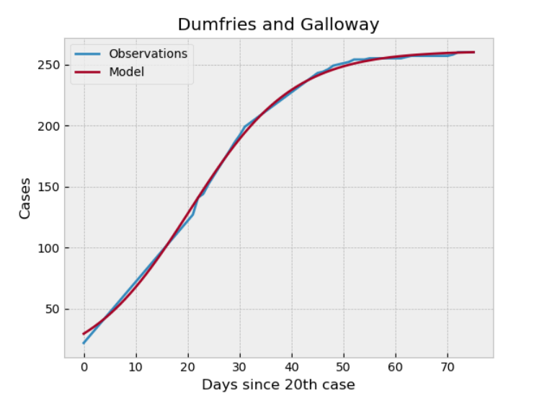

**RESULTS & DISCUSSION**

We started investigating the total number of active cases per administrative county in the UK

Based on BING data:

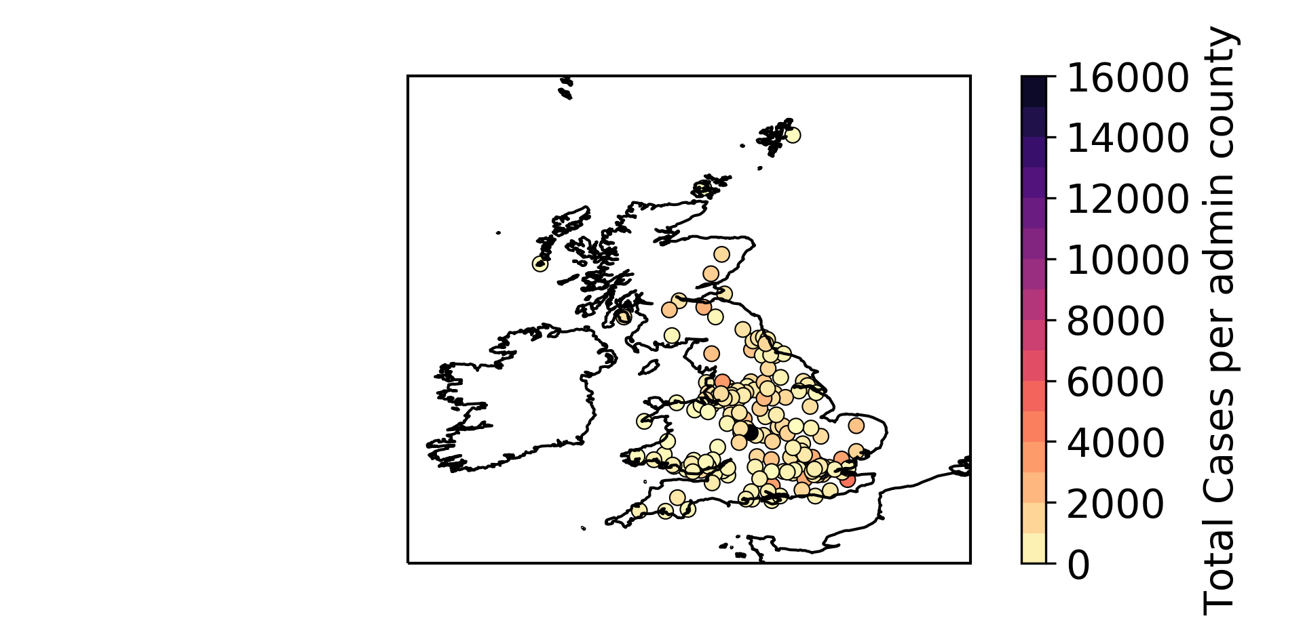

IndIviduals timeseries were then fitted and plotted as shown for Dumfries and Galloway.

We then extracted for each county the growth rate and inflection point, the latter representing the peak of the epidemic according to the logistics model fitted to data. In order to look for correlation between COVID-19 cases and human factors, NASA earth data were extracted as GIBS files from Worldview and merged with the dataset containing each UK county location and associated ONS data. For a quick overview of the type of fields used see below an example of amount of impervious land and population density at night

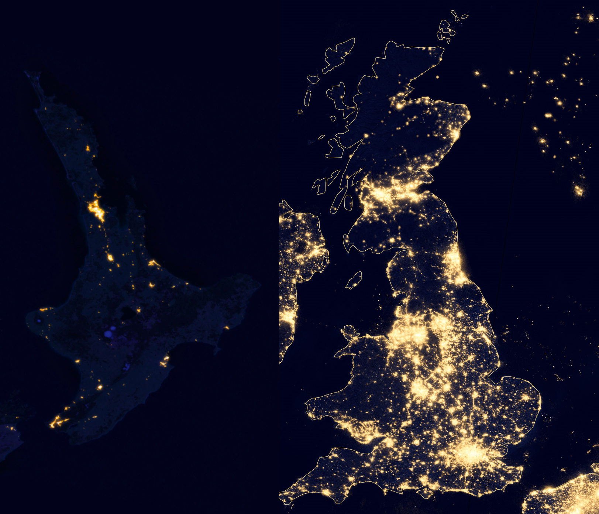

As shown by the correlation below between growth_rate, inflection_point and cases at day0 with impervious land, settlement area and land traffic :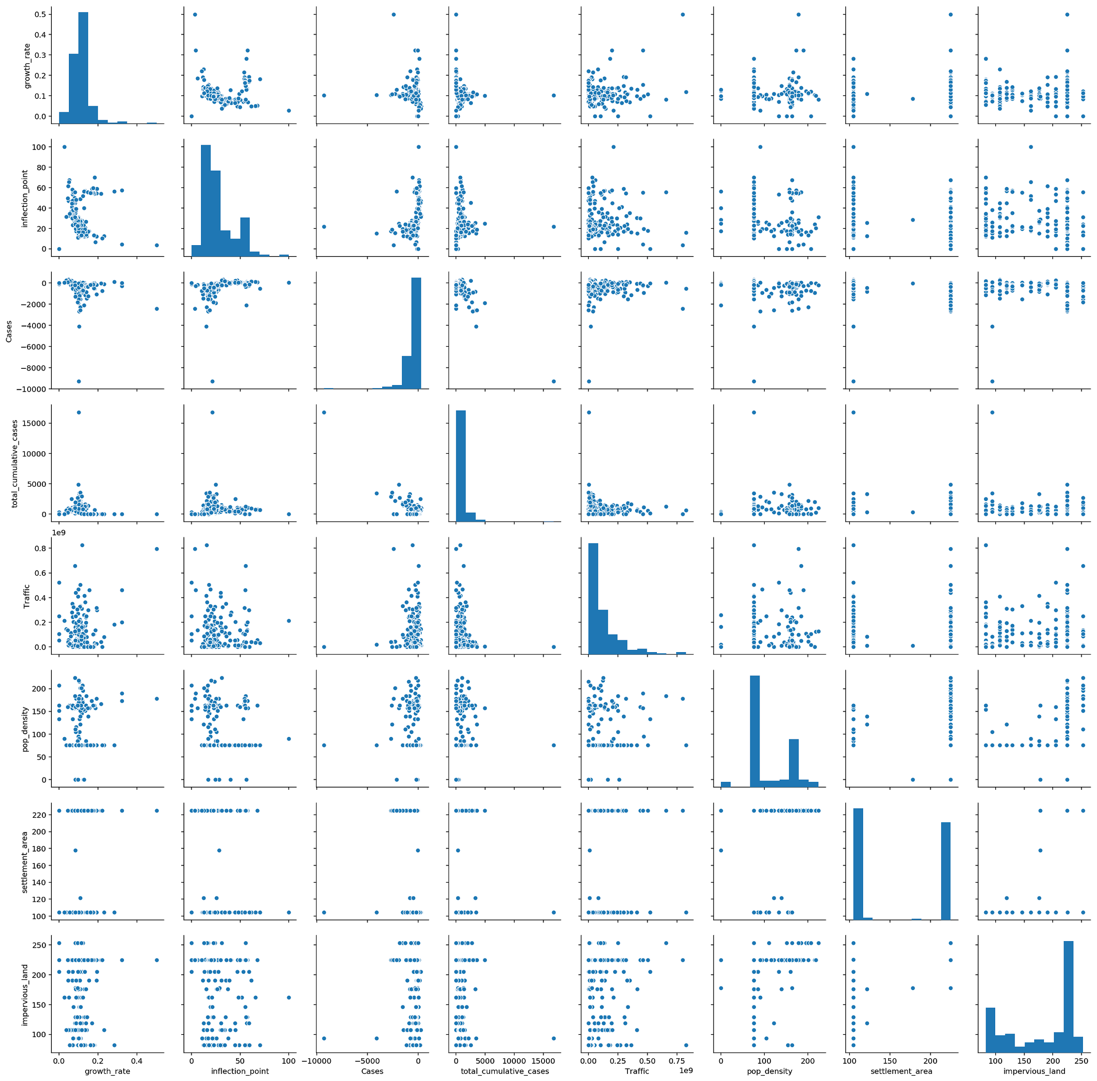

Individual correlations between human factor parameters population density, land traffic, integrated density of infrastructure did not yield consistent results. That indicates that a single variable is not sufficient to explain the variability of the logistic curve parameters, i.e. growth rate and epidemics peak. Instead, it seems to be associated with a combination of factors particular to each location**.**

However, analysis of 11 major UK cities revealed correlation between (passengers, paxes) air traffic (-0.26) and covid-19 epidemics peak.

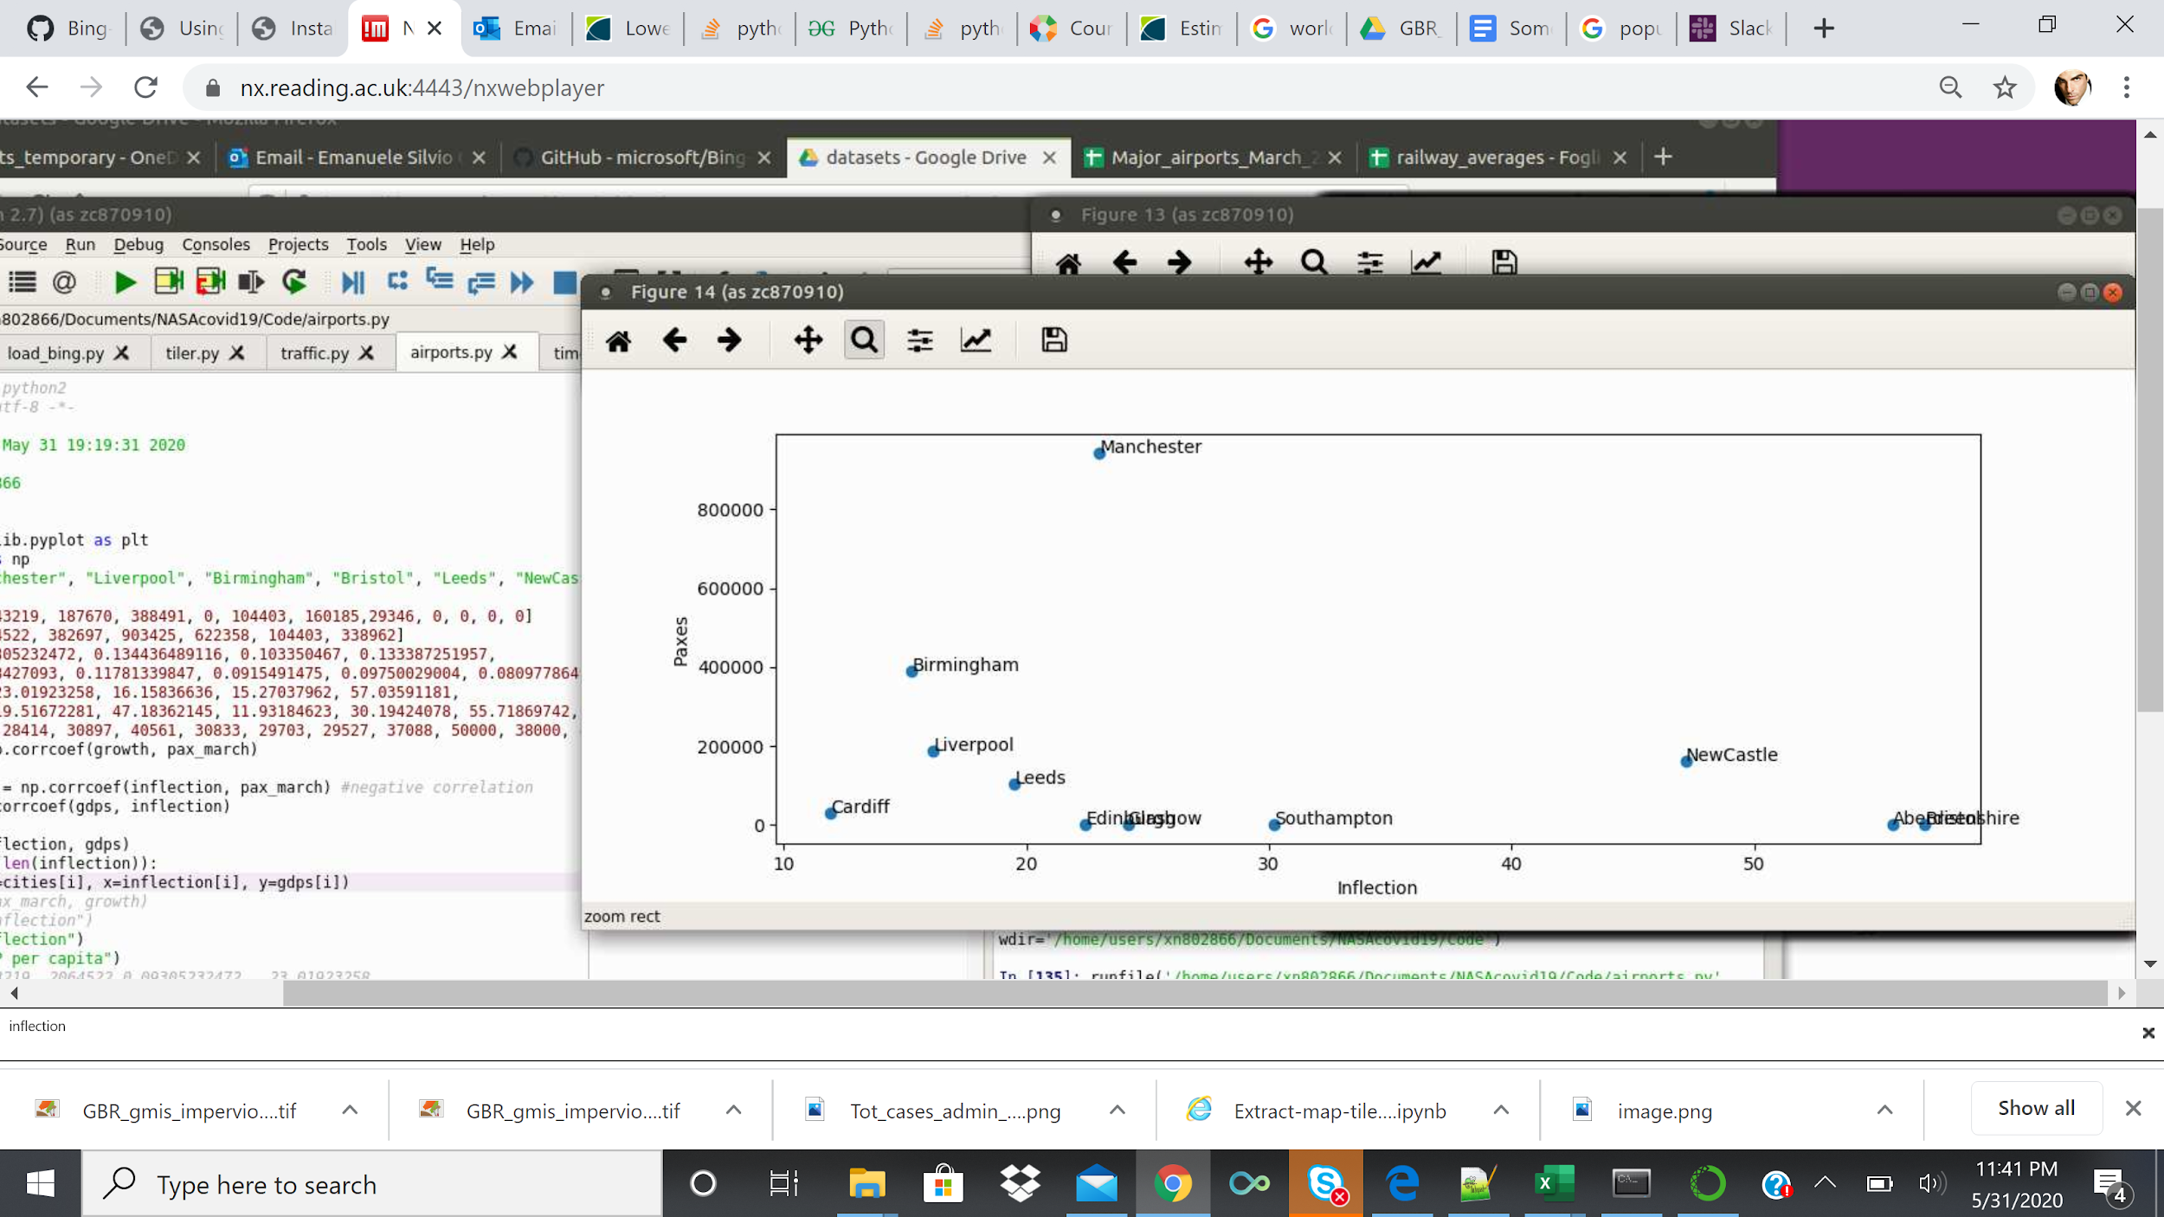

Individual breakdown below shows that cities with same impervious land and land traffic who shut down their airport were more successful in slashing the epidemics peak and growth rate.

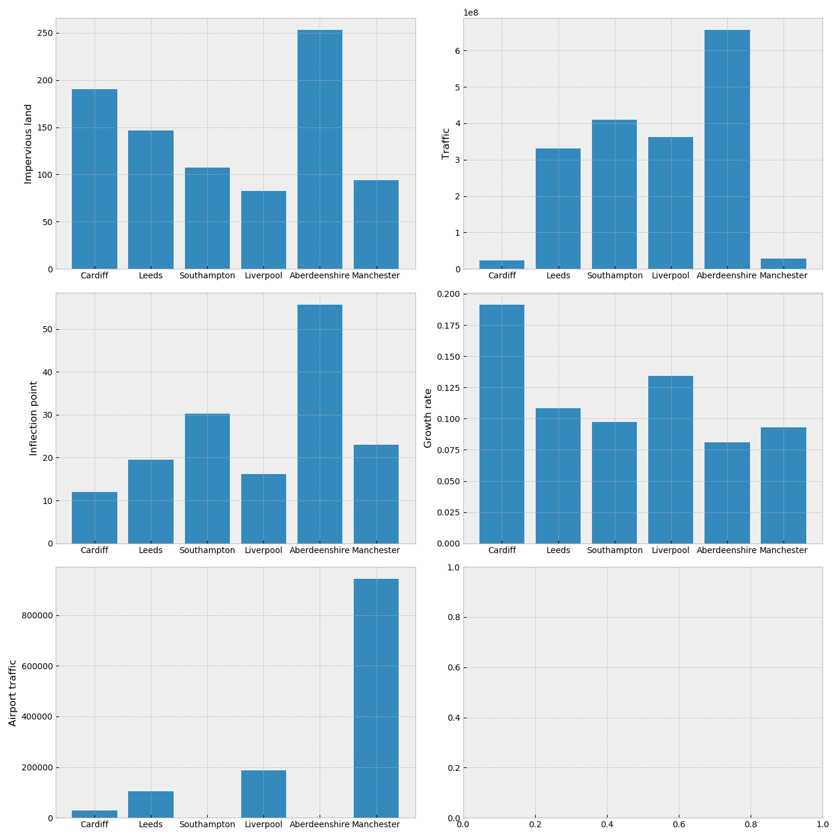

And even stronger correlation (0.64) between gdp per capita and epidemics peak highilighting that lower-income cities were more at risk of being more badly affected by the covid spread.

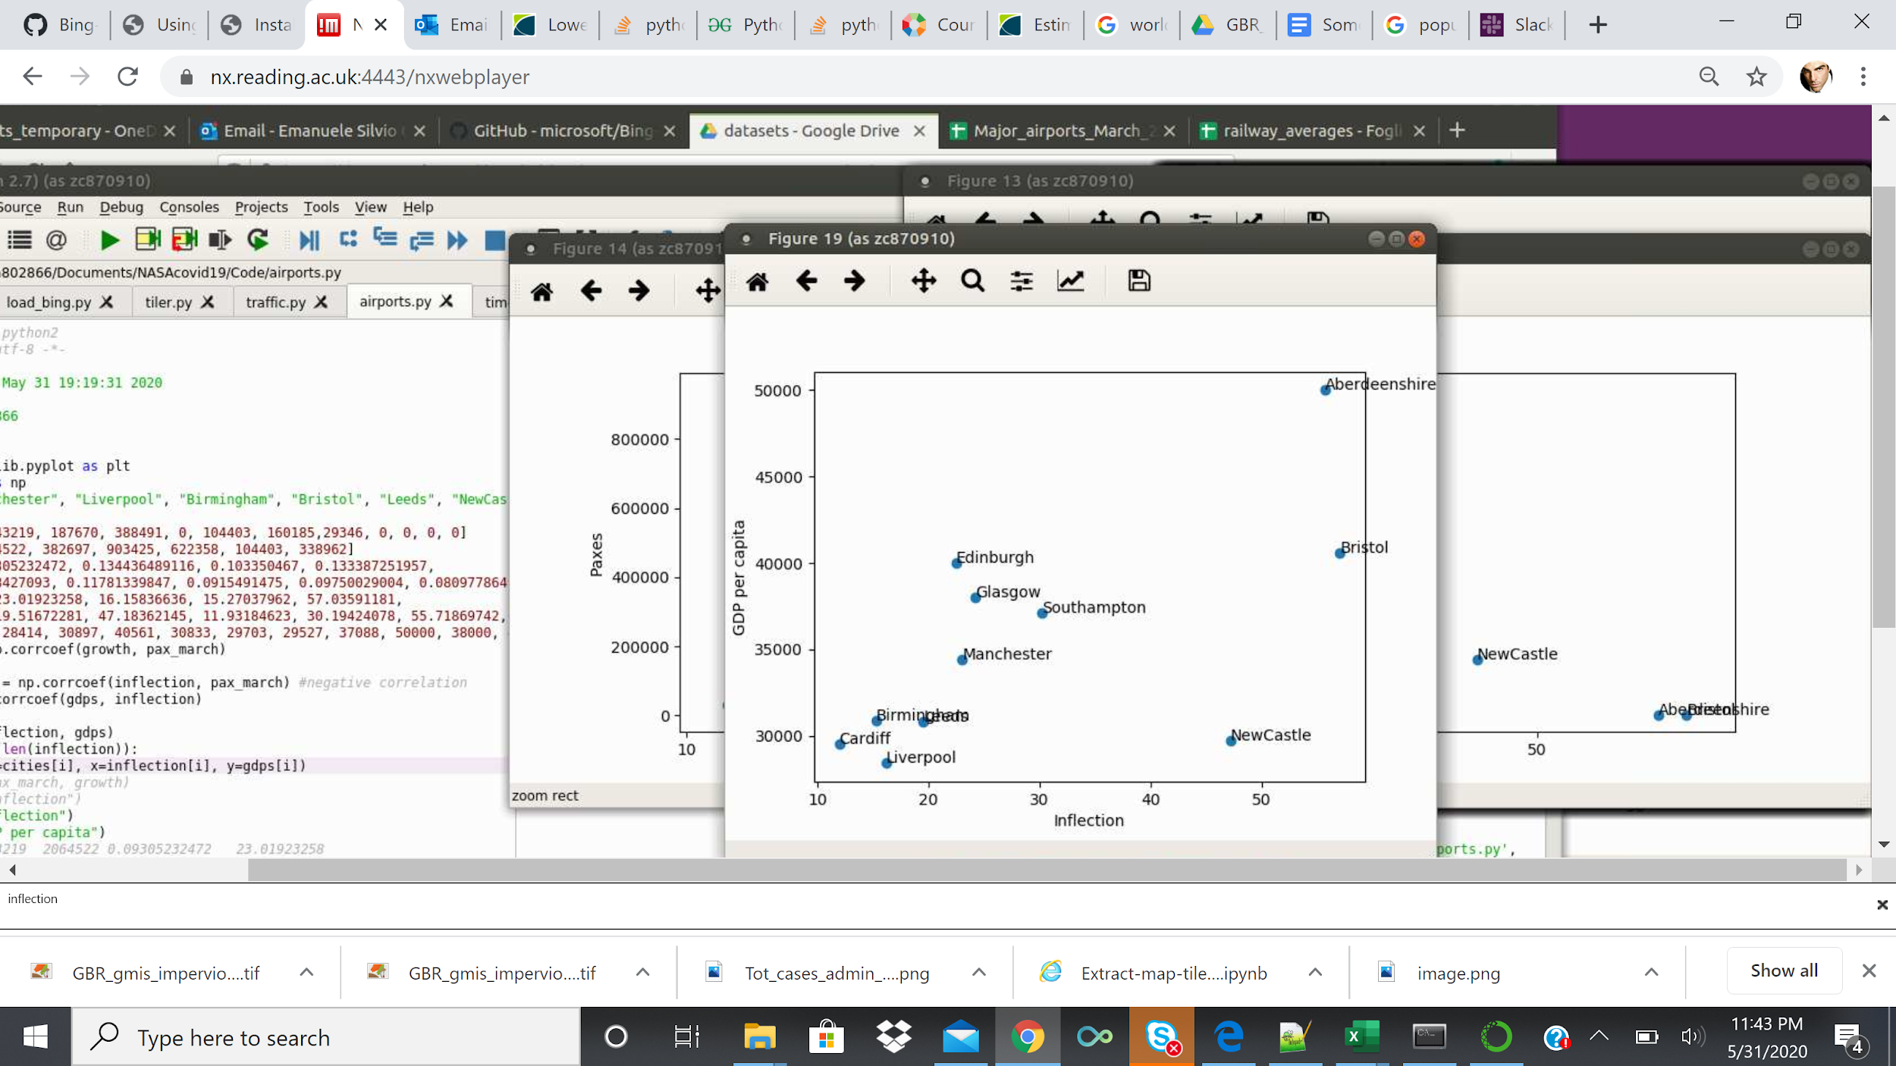

**Suggestion to policymakers**:

* Quarantining all incoming air travellers for 15 days in controlled structures will help preventing a second wave of infections
* Intensify testing & track and trace in poorer GDP areas